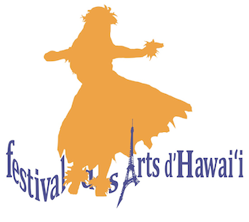
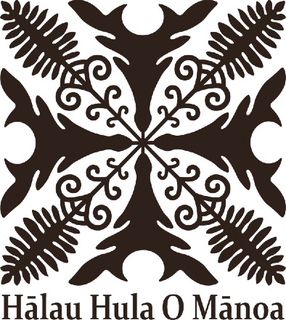
Hawai‘i Arts Festival 2018
HO‘OLAULE‘A HULA I PALISA
Celebrating Hula in Paris ❀ June 29 – July 2, 2018
SPECIAL HULA WEEKEND PROGRAM

FRIDAY, JUNE 29

Hulu Kūpuna ❀ Hō‘ike + Kanikapila ❀ Hālau Mele & Hālau Hula O Mānoa 19:00
Casual evening of Hawaiian music and dance on the Seine River, with a special commemoration for nā kumu George Holokai, Ellen Pukaikapuaokalani Castillo, John Keolamaka’āinana Lake. We invite everyone who has received hula from these cherished kūpuna to get up and dance with us! (Please let us know, if possible)
Hawaiian-style food will be served!
The event is FREE, but food and drinks are not included

SATURDAY, JUNE 30 : KA LĀ ‘AUANA
‘Ukulele workshop ❀ Māhealani Wong & Hālau Mele 10:00 - 11:30
Learn to play the mele for the hula ‘auana that will be taught in the afternoon
(All levels, but previous knowledge required)

Hawaiian crafts ❀ Nā mea hana lima: Hulu (feathers) ❀ Hālau Mele 10:00 - 11:30
Make a pua hulu, feather flower.

Hula ‘Auana workshop ❀ Kilohana Silve 13:30 - 16:30
Learn a lovely ‘auana and the story about a special place in Hawai’i.

Hawaiian crafts ❀ Nā mea hana lima: Lauhala ❀ Hanalei Marques 16:30 - 18:30
Make a pe’ahi, Hawaiian fan, from hala leaves.
The number of participants is limited, so sign up as early as possible!

Ho’olaule’a Europa ❀ Everyone! 19:00
We would like to invite all of our European hula sisters and brothers to join us in a special evening of dancing and celebrating hula amongst ourselves in a historic old-style Parisian café. This is where you get to dance your own hula in a fun and friendly atmosphere!
(For those who want to dance, please see details on the sheet: Ho’olaule’a Europa INFO).

Please sign up for the workshops on the sheet: SIGN-UP & PRICES Sheet2

HO’OLAULE’A HULA I PALISA ❀ Celebrating Hula in Paris ❀ June 29 – July 2, 2018
SPECIAL HULA WEEKEND PROGRAM / p. 2

SUNDAY, JULY 1 : KA LĀ KAHIKO
Oli and Protocol workshop ❀ Sam ‘Ohukaniʻōhiʻa Gon 10:00 - 12:00
Learn an oli, chant, along with the rituals and protocols for gathering plants, a vital element of Hawaiian culture and hula.

Hula Kahiko workshop ❀ Māhealani Wong 13:30 - 16:30
We need YOUR opinion on this wikiwiki!
Kumu Māhea has suggested a hula ‘ili’ili (with pebbles), which is rarely taught in Europe. Ideally, you would come with your own ‘ili’ili, which you can gather locally at a lake, river or by the seaside. However, if this is too complicated, she will teach a hula kahiko without instruments. Please let us know what you think when you sign up!

Mo’olelo & ‘Ōlelo ❀ Kalama Cabigon 16:30 - 18:00
A storytelling session to “immerse” you in the spoken language, a fun, novel way to experience the beauty, sounds and rhythm of ‘ōlelo Hawai’i (Hawaiian) as well as to learn some new words. No prior knowledge needed, everyone is encouraged to attend!

MONDAY, JULY 2
Hawaiian crafts ❀ Nā mea hana lima: Hulu (feathers) ❀ Hālau Mele 14:00 - 16:00
Make a pua hulu, feather flower. And for dancers, this is an opportunity to make your own kūpe’e (bracelet or anklet).

Nānā I Ke Kumu (Look to the Source) ❀ Performance, Théâtre Douze, Paris 20:15 – 21:45
We close our Hula Weekend and Festival with a unique opportunity to see an authentic hula kahiko and ‘auana performance by one of the most distinguished hālau from Hawai'i for the first time ever in France. True to their kuleana to both honor and be kumu, sources, Hālau Mele will not only perform dances, chants and live music, but will include accompanying explanations in order to provide European audiences with a broader understanding of Hawaiian culture and hula.
The hula perpetuated and created by Hālau Mele are not seen in competitions, they are performed for ceremonies, rituals, to honor the ‘āina, the ‘ike, the kūpuna , the traditions. This is another facet, another purpose of hula, one that is much less visible, especially here in Europe.
Nānā I Ke Kumu will be unlike any other performance you are likely to see, a very complete, very unique experience, and a “must” for anyone who loves hula and wants to know more about the kumu, the sources of hula.

Please sign up for the workshops on the sheet: SIGN-UP & PRICES Sheet2
Questions: hulafadh@gmail.com
festivalartsdhawaii.com/hoolaulea.html
HĀLAU MELE
Nā Waʻa Lālani Kāhuna o Puʻu Koholā – Nā Hanona o ka Hālau Hula Pā Ola Kapu

HĀLAU MELE was founded by one of Hawai’i’s most respected Kumu Hula, John Keolamakaʻāinana Lake (1937-2008), a master of Hawaiian religion and cultural protocols who earned the title of "Living Treasure of Hawai’i". He was Kahuna Nui (chief priest) of Pu'ukoholā Heiau and devoted his life to perpetuating ancient chant, rituals, and ceremonies. Hālau Mele is comprised of two specialized schools: Nā Waʻa Lālani Kāhuna o Puʻu Koholā (oli, chant) and Nā Hanona o ka Hālau Hula Pā Ola Kapu (hula, dance). Kumu Lake passed on the sacred responsibility of continuing the hālau to two of his ʻūniki (traditional rites of passage) graduates, Kumu Hula Kathryn Māhealani Wong and Kumu Oli Sam ʻOhukaniʻōhiʻa Gon III. Hālau Mele performs at the yearly Ho’okū’ikahi Festival at Pu’ukoholā Heiau, with the task of perpetuating the past through traditional hula and oli, as well as commemorating people and events by creating new hula and oli. It is a non-competitive hālau that focuses on preserving Hawaiian tradition in the most authentic way, and it is the hālau-in-residence at the Bernice Pauahi Bishop Museum.
Link to a video on Hālau Mele: www.youtube.com/watch?v=P1cavxSxNOc&feature=youtu.be

Māhealani Wong studied hula over many years with nā Kumu Hula Hoakalei Kamauʻu, Pōmaikaʻi Gaui, and after her ʻūniki (graduation) under Kumu John Keolamakaʻāinana Lake, was designated Kumu Hula and Kahuna Kākalaleo (chant & protocol master), entrusted with the kuleana of perpetuating the hula for Hālau Mele’s Nā Hanona o ka Hālau Hula Pā Ola Kapu. Under her direction its members perform as court dancers for the Ho’okū’ikahi Festival at Pu’ukoholā Heiau on Hawaiʻi Island. She is also a Kahuna Kākalaleo in Mailekini, the adjoining heiau used by women.
Māhealani has been called on to share her knowledge of traditional hula, oli and protocol at home and abroad, serving as a Kumu Hula for the Mana Maoli collective in Aotearoa (New Zealand) and as the Official Chanter for the canonization ceremonies for Saint Damien of Moloka’i, held in Belgium, where she had the honor of chanting at his birthplace and for the royal family, and at St. Paul’s Cathedral in Rome in 2009. She also teaches hula, ‘ukulele and Hawaiian Studies to students at the Honolulu Waldorf School.

Sam ʻOhukaniʻōhiʻa Gon III is a Hawaiian cultural practitioner and conservation ecologist. He studied dance and chant with several Kumu Hula including Hoʻoulu Cambra and Edward Kalāhiki. His training with Kumu John Keolamakaʻāinana Lake culminated in his ʻūniki as a Kahuna Kākalaleo, a practitioner of chant and protocol. He is the Kumu Oli for Hālau Mele’s Nā Waʻa Lālani Kāhuna o Puʻu Koholā and a Kahuna Pule (prayer master) for Puʻukoholā Heiau.
Dr. Gon is also a renowned conservation biologist who is dedicated to protecting and restoring the ecosystems native to the islands. He is the Nature Conservancy of Hawaiʻi’s Senior Scientist and Cultural Adviser and he has lent his expertise to international projects around the world. As a distinguished public speaker, he has lectured at The Smithsonian National Museum of the American Indian (Washington, D.C.), Ethnologisches Museum Staatliche Museen zu Berlin (Germany) and the Museum Nationale d’Histoire Naturelle (France).
For this unique blend of Hawaiian culture and ecology, he was named a “Living Treasure of Hawaiʻi” in 2014.
http://www.hawaiiecoregionplan.info/samgon.html

HĀLAU MELE

Marques Hanalei Marzan is a Hawaiian fiber artist who trained under master weavers such as Julia Minerva Ka‘awa and Esther Kakalia Westmoreland. He is a designer and specialist in Hawaiian cordage and textiles who has been distinguished with many awards for his art. He has represented Hawai‘i in numerous indigenous art festivals, including the Festival of the Pacific Arts and the Smithsonian Folklife Festival. He shares his understanding of and passion for the fiber arts through presentations and workshops that restore, in modern culture, the living presence of rare Hawaiian forms, materials, and designs.
Hanalei Marzan also studied hula and oli under Kumu John Keolamakaʻāinana Lake. After his ‘ūniki, he became a Kahuna Kākalaleo, skilled in the practice of Hawaiian chant and protocols, and he is a Kahuna Pule (prayer master) for Pu'ukoholā Heiau. He currently serves as cultural advisor at Bishop Museum, the Hawai‘i State Museum of Natural and Cultural History.
http://www.marquesmarzan.com

Kalama Cabigon is a fluent speaker and teacher of ʻōlelo Hawaiʻi, and a lifelong scholar of Hawaiian culture, history, and language. He studied oli and traditional Hawaiian protocol under Kumu John Keolamaka’āinana Lake for many years. He serves as Kahuna Pule (prayer master) for the ceremonies at Pu'ukoholā Heiau and is the kahu (guardian) of the Ho’āla sunrise rituals held weekly on Waikiki Beach in Honolulu.
Kalama has also made a name for himself as a storyteller, musician and slam poet. Exercising his art with passion as well as humor, he has been invited to tell stories in ‘ōlelo Hawai’i and English at the Bishop Museum’s Mary Kawena Pukui Storytelling Festival and at Honolulu's Annual Talk Story Festival. Kalama has performed and toured in several productions with the Hawaiian language theater group Ka Hālau Hanakeaka and most recently in a production of Pakaʻa a Lanakila with the Hawaii Spring Wind Quintet. He is also a member of the group Kupa’āina, which combines Hawaiian music with contemporary genres such as rock, hiphop and reggae.

HĀLAU HULA O MĀNOA
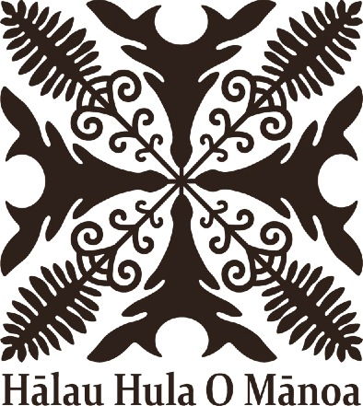

HĀLAU HULA O MĀNOA was founded as the first and only traditional Hawaiian dance school in France by Kumu Hula Sandra Kilohana Silve in 1992. Although she moved back to her home in Mānoa Valley on the island of O’ahu in 2005, she returns to Paris on a regular basis. Classes are now taught by alaka’i throughout the year. The hālau is proud to preserve the lineage of two renowed and beloved Kumu Hula, Ellen Pukaikapuaokalani Castillo and George Holokai. It offers a complete program of training in all of the traditional arts, including hula kahiko and 'auana, oli, lei-making, ‘ukulele, and Hawaiian history and culture.
With branches now in Honolulu, Rome, and Juno (Alaska), Hālau Hula O Mānoa has participated in the Festival Paris Quartier d'Eté, Festival Escales d'ailleurs in France, the World Invitational Hula Festival in Honolulu and Chigasaki (Japan) and the Ho’okupu Hula No Lana’i Cultural Festival on the island of Lana’i. In conjunction with the Association France-Hawai’i, which promotes Hawaiian culture in France via cultural and artistic exchanges, Hālau Hula O Mānoa began organizing the first festival in France dedicated to hula and Hawaiian culture in 2012.

Kilohana Silve received her foundation in hula and choreography from Kumu Hula Ellen Pukaikapuaokalani Castillo. She had the privilege of studying with Hula Master George Holokai, and was amongst the ‘ūniki graduates of Kimo Alama Keaulana’s Lei Hulu Papa ‘Uniki ‘Ehā. She continues to study oli with Sam ‘Ohukani’ōhi’a Gon of Hālau Mele. As a storyteller, Kilohana Silve has participated in the Annual Talk Story Festival in Honolulu and released a CD of Hawaiian tales, chants and music.
Kilohana Silve has always sought to promote Hawaiian culture abroad by curating exhibitions as an art historian and through a cross-cultural approach to hula. She founded the first Hawaiian dance school in France, Hālau Hula O Mānoa, named after the valley in which she was born. After 30 years in Paris, she returned to Hawai’i and continues to teach haumāna in Honolulu, Juneau (Alaska) and Beijing (China).
Through her classes at Kapi’olani Hospital Women’s Center, Kokua Kalihi Valley clinic and the Salvation Army’s drug recovery program, as well as her involvement in the Ola Hou I Ka Hula study conducted by researchers at the University of Hawai’i and Queen’s Medical Center, she has become a pioneer in the promising new field of Hula for Health.

